**Introduction**

In this age of modern technology generation, people may readily obtain the information they want through Internet. The Internet is an essential component in human life as it provides individuals with endless knowledge and entertainment. For example, when there is no Internet, people must market their shops by publishing through newspaper or passing out leaflets, which is inefficient because it is depends on geographic location. However, since the advent of the Internet, store owners merely need to promote on social media to attract clients from all over the world. Hence, in this assignment, our group is going to develop a website to promote a restaurant. The restaurant that we promoted is a Japanese-based restaurant which is called x restaurant. It sells sushis like Nigiri, Gunkan, Maki, Tsunami, and other Japanese foods. Whoever interested in dining at x restaurant can visit this website. This website can let the customers to understand this restaurant quickly. It includes information such as menu, promotion news, location, and provide customer services. The reason that the website contain information like menu and promotion news is because the customers can think first about what to eat and get e-vouchers so that the customers would not end up in long queues and save time. Besides that, if customers are not satisfied with the restaurant or if there is potential for improvement, they can provide their opinions through customer services. For location webpage, they can find the nearest x restaurant. In short, this website interpret the characteristics of this store to attract customers.

**Literature Review**

The existing website that I choose to compare with our website is Arngren.net [1]. The first criteria that I want to compare is the arrangement of the website. For Arngren.net, it places the contents everywhere and the contents do not arrange in row and column. If there is a white space, it will be filled with the contents. This makes the users feel frustrated and dazzles when viewing the website.

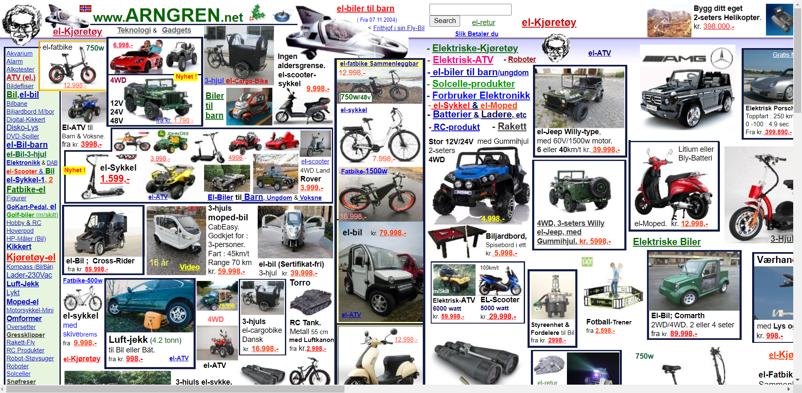

For our website, the arrangement is tidier as all the contents are store in the containers and the containers are arranged according to row and column format. The gap between each container makes the content not crowded.

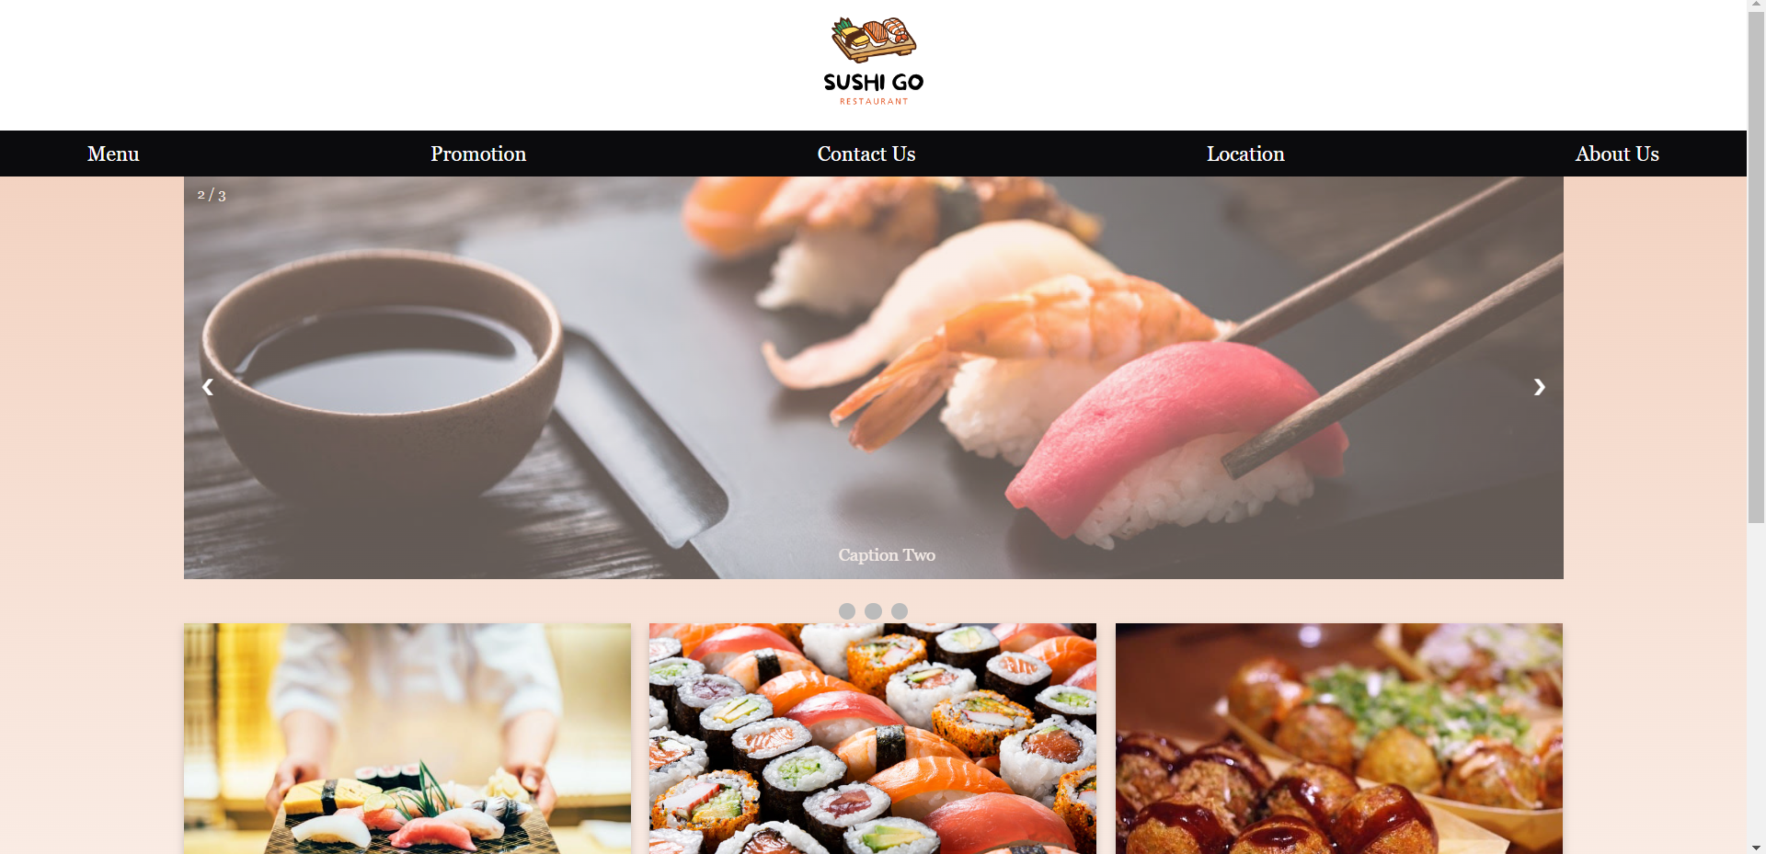

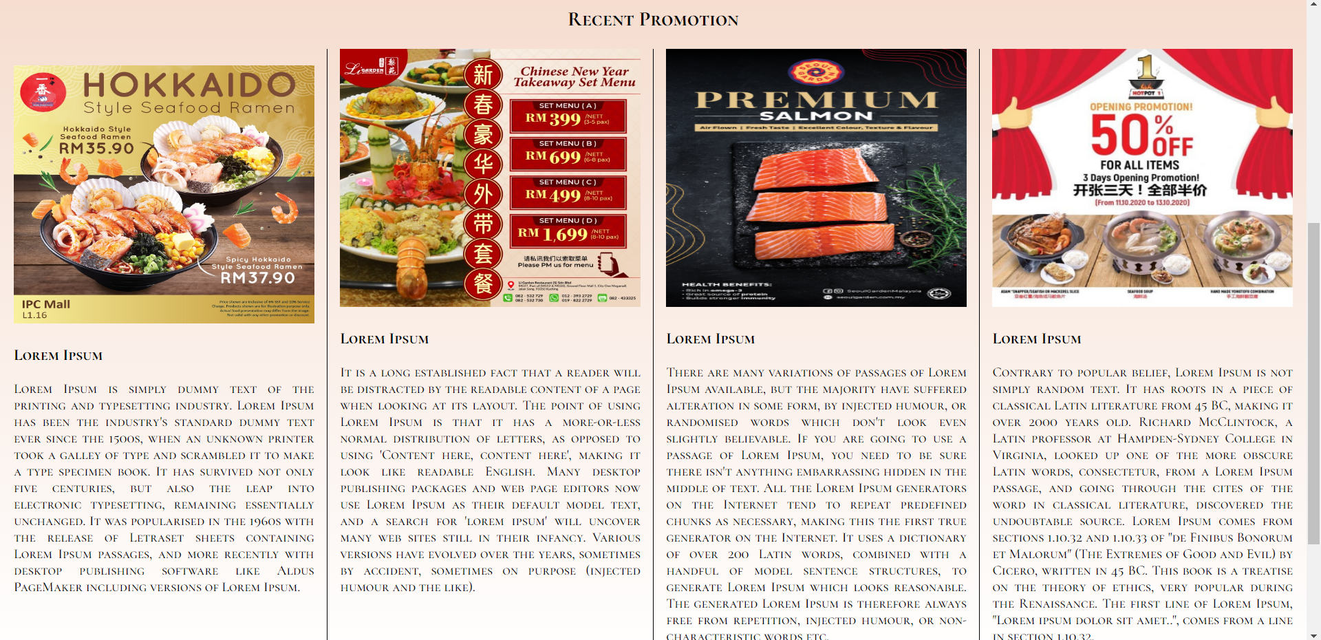

Besides that, the arrangement of the images and the text inside the containers are not standard. For example, some texts will be placed at the left side of an image while some texts will be placed at the top of an image.

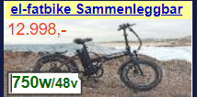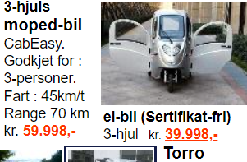

For our website, the format of texts and images are standardized in every container. All texts in a webpage are either located at the top of images or bottom of the images.



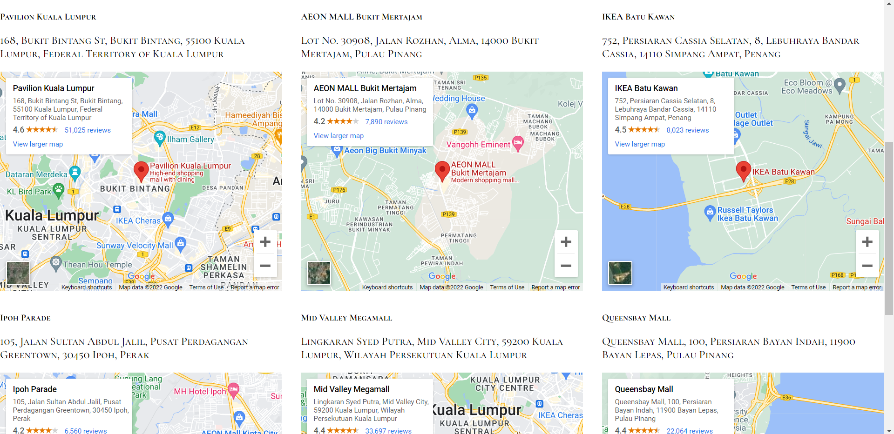

Next, the width of the Arngren.net are not fully used. When the webpage is scrolled to the right side, there is many white spaces that has not be used. If there are many unwanted white spaces, the developer should not set the width so long.

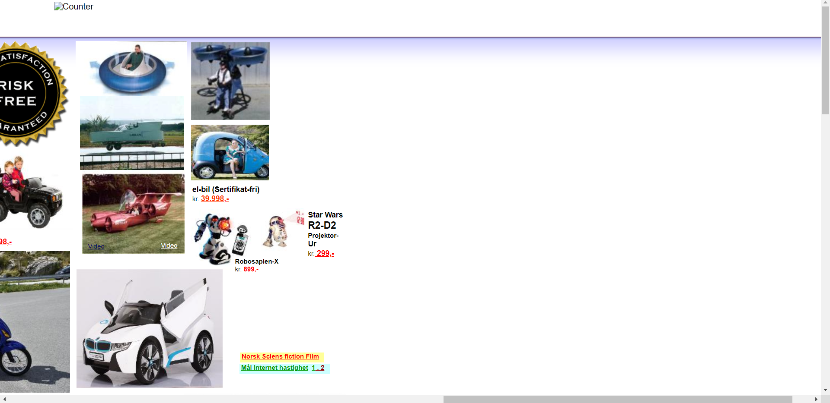

For our website, all the white spaces are fully used. The website cannot be scrolled to the right side as all the contents already fit into a screen so that the user can view at a glance.

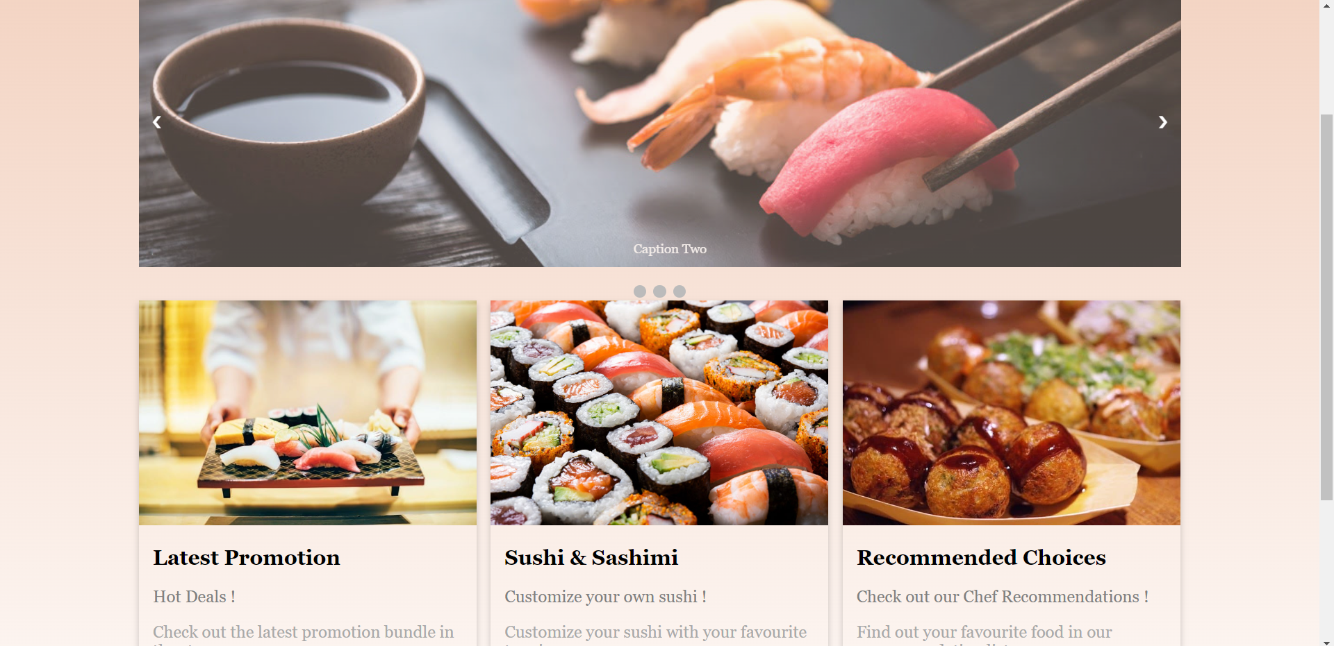

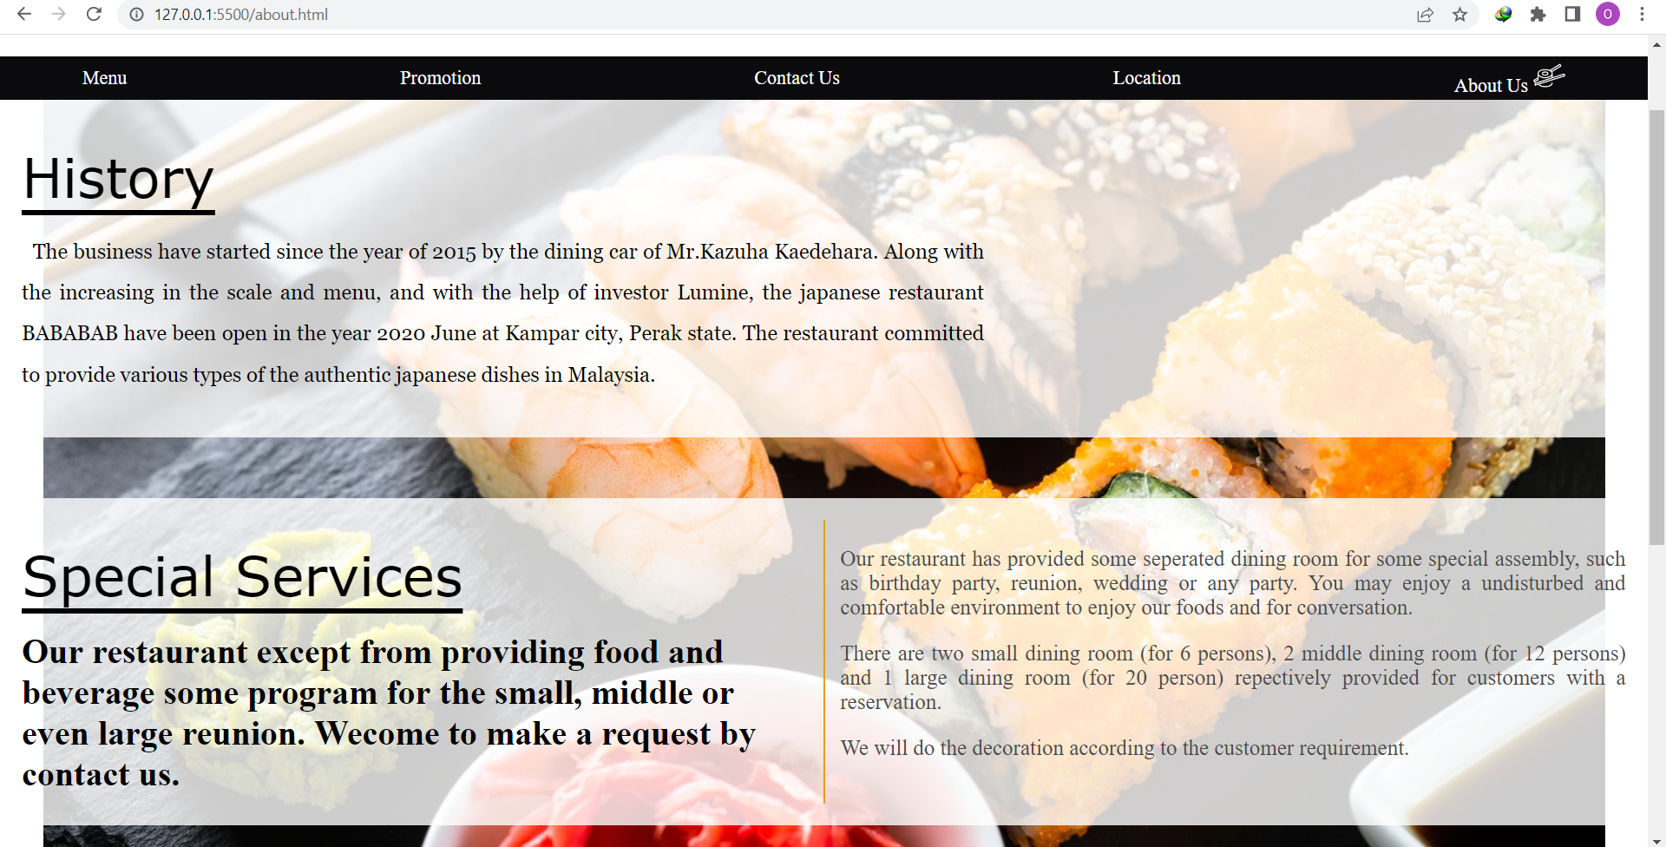

Moreover, Arngren.net is not a responsive website. When change to the mobile viewing mode, the arrangement of the website is still same. The contents have exceeded the mobile screen and those exceed contents cannot be view by mobile user. The website only has window viewing mode, but even for window viewing mode, the whole website cannot fit to the window screen.

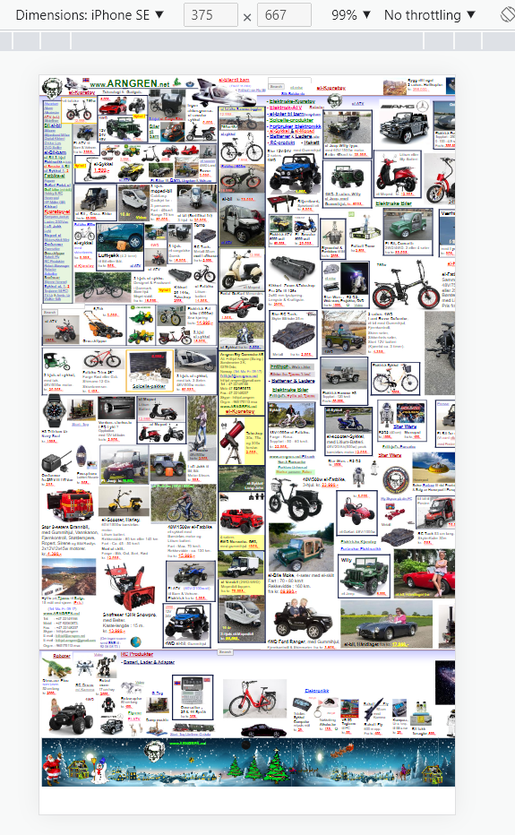

For our website, it is designed in responsive. The viewing screen of our website will change according to the device’s screen.

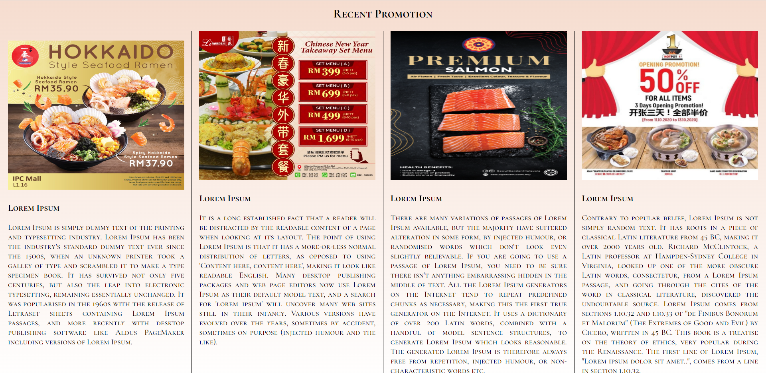 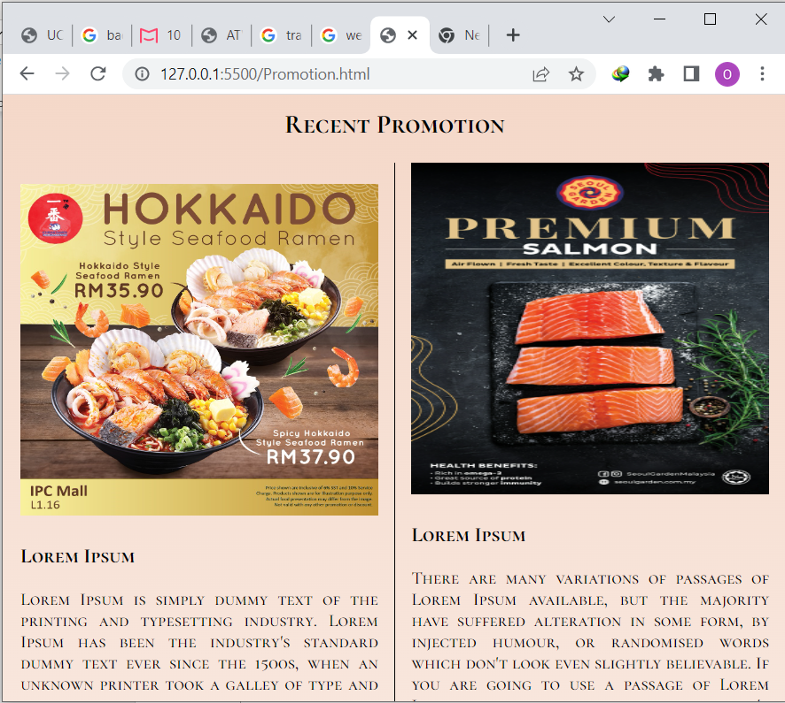

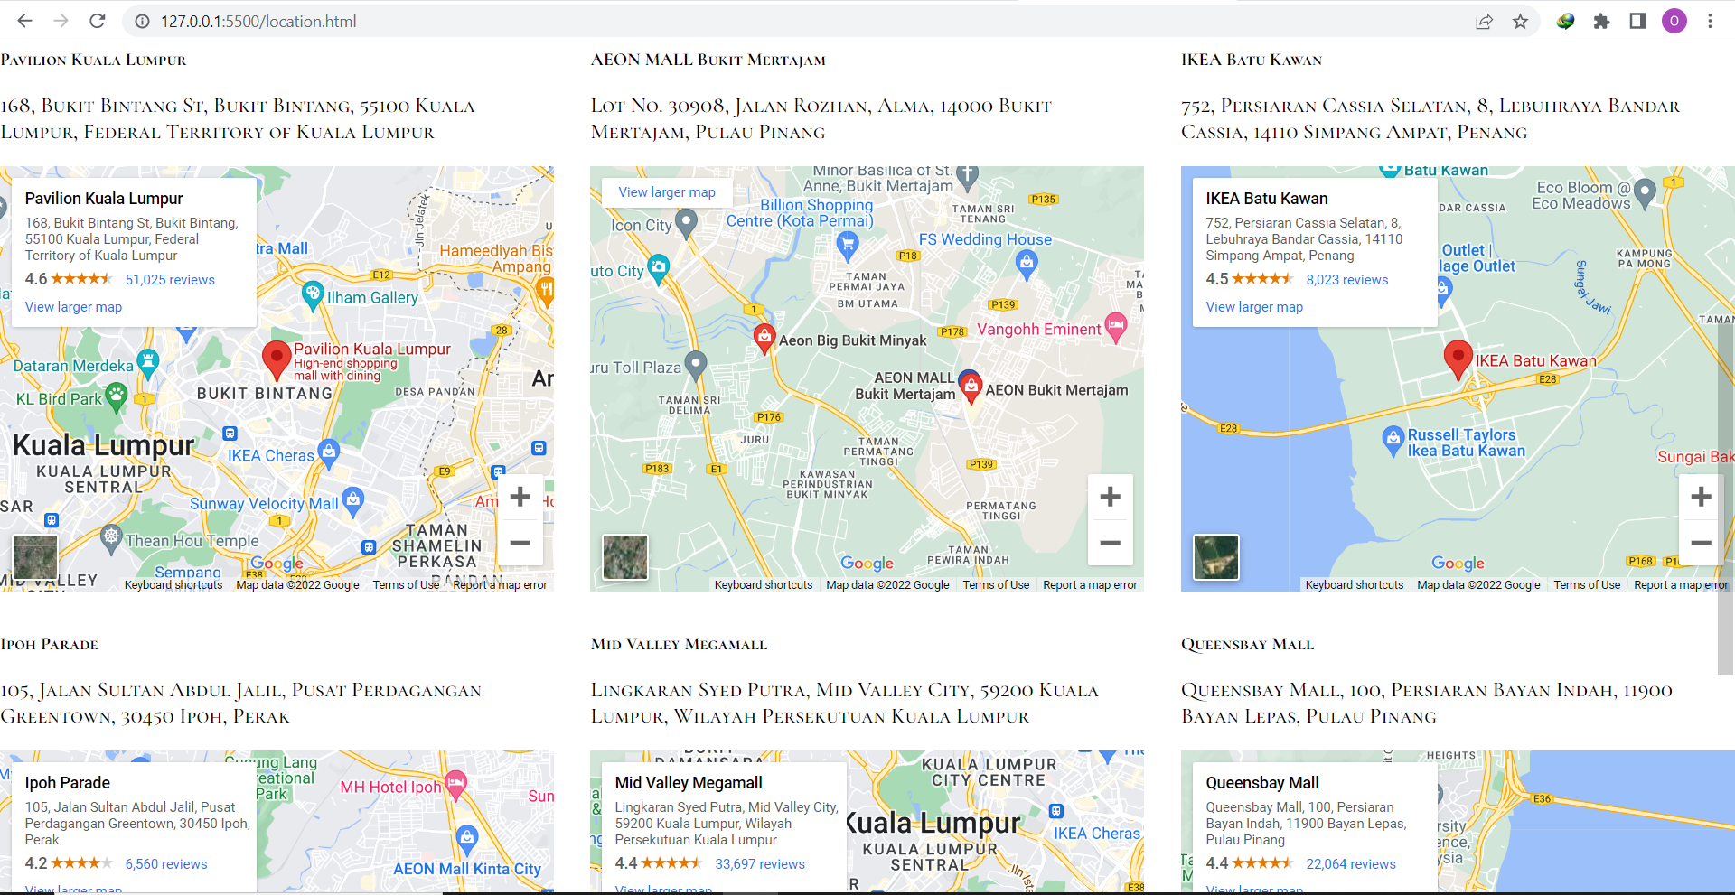 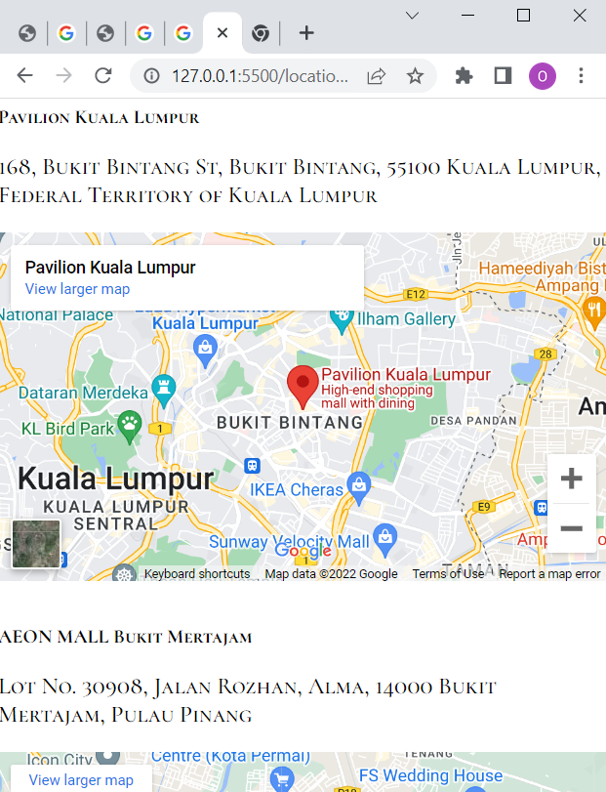

However, there are some limitation to our website. First, in the location webpage, for the Google Map, the user cannot input the address he wants to find the location, the user can only scroll the Google Map to find the address he wants.

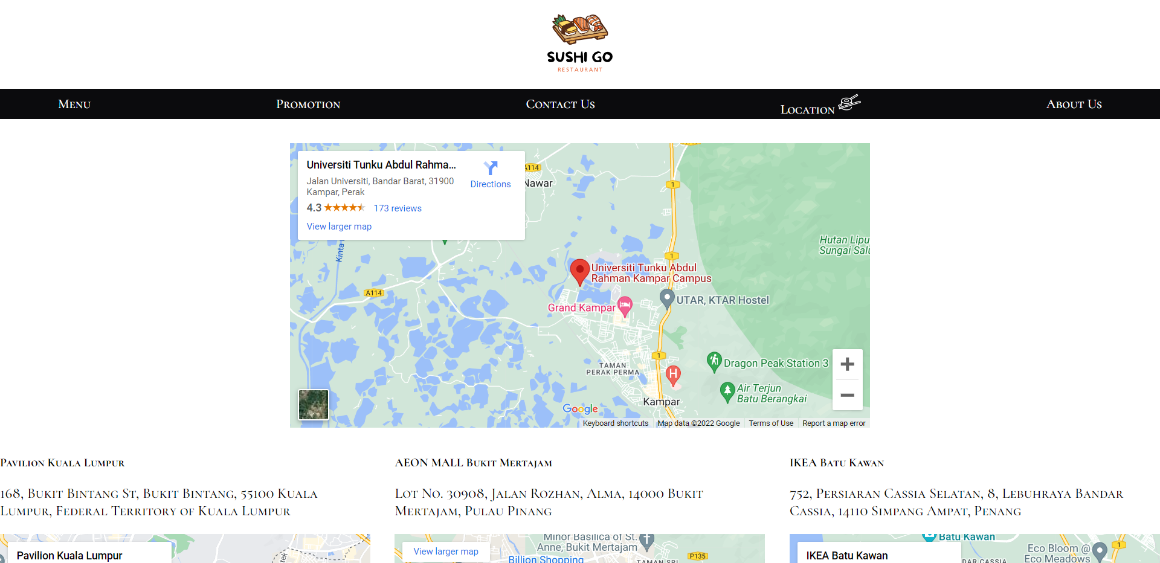

Second, the slideshow in promotion webpage cannot move automatically. The user needs to click the radio button to view next slide.

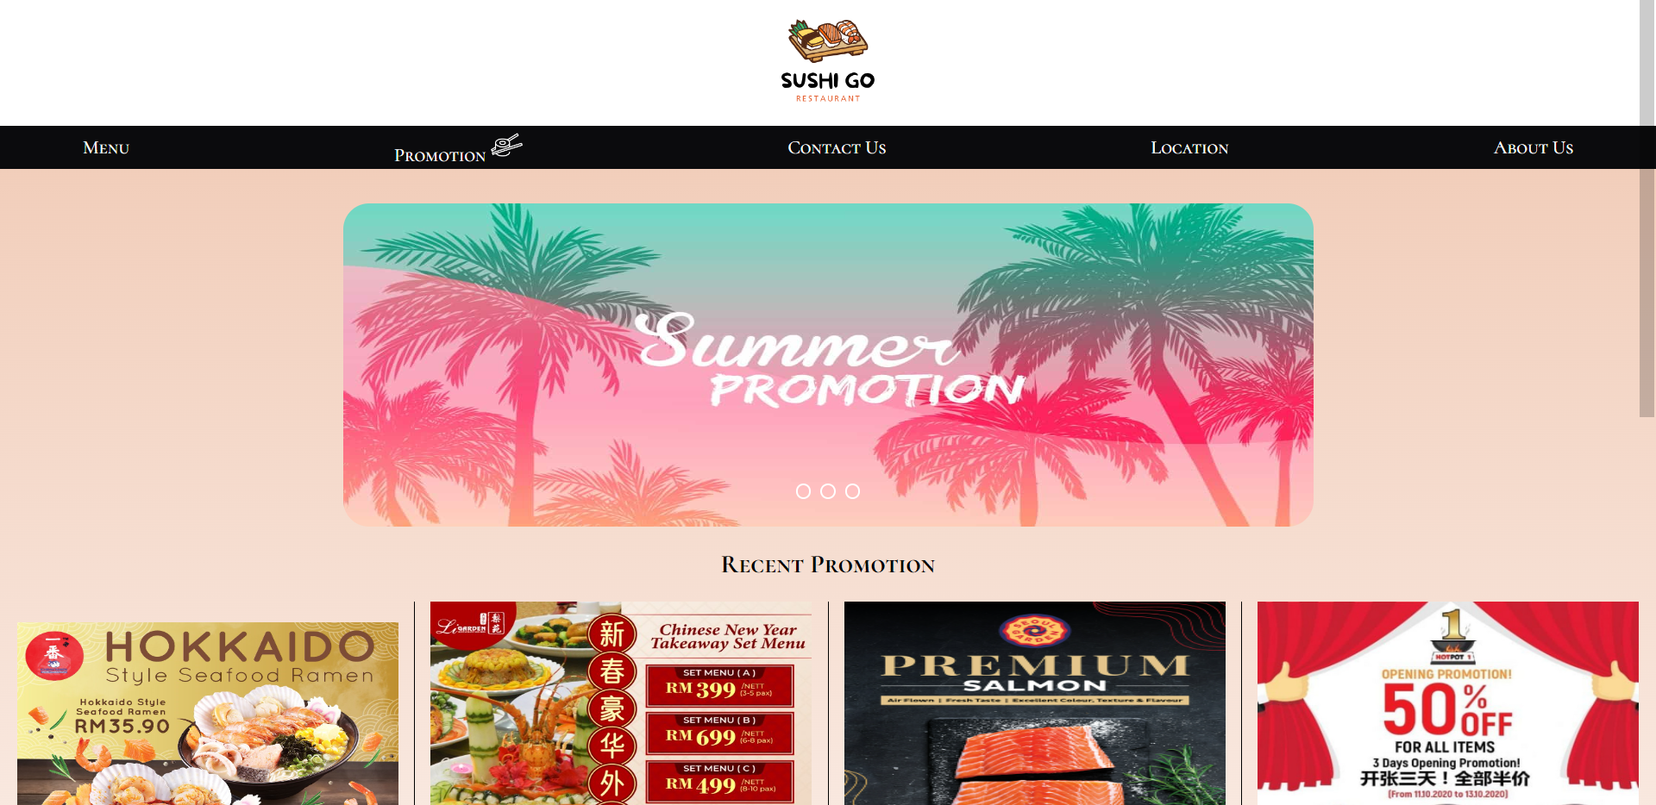

Hence, I will recommend our team to create a website that can let user to input address and find the location. And I will recommend our team to create a slideshow that can move automatically and can click radio to move at a same time.

**References**

|  |  |
| --- | --- |
| [1] | F. Arngren, "www.ARNGREN.net," Arngren Sky Commuter AS, [Online]. Available: https://arngren.net/. [Accessed 23 August 2022]. |